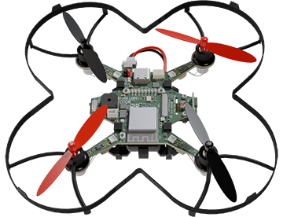

|  |  |
| --- | --- |
| **CodeAIR Mission 5 Assignment** | **Name:** |
| **Pre-Mission Preparation** | |
| What are some of the things you coded in the safety.py program? |  |
| What are some safety precautions you should take before flying a drone? |  |
| **Mission 5 Checks – Hovering Flight** | |
| Objective #1  How do you make your safety.py program into a custom module? |  |
| Objective #2  The sensors for altitude are:  The sensor for tracking and holding position is:  What are three commands the MotionCommander executes? |  |
|  |
|  |
| Objective #3  What is the difference between a blocking function and a non-blocking function?  What are distance and velocity measured in? |  |
|  |
| Objective #4  What component is used to keep the drone flying at a desired altitude?  What line of code returns its data? |  |
|  |
| Objective #5  Click on  variable. Give at least one fact you learned from the toolbox.  What code unpacks the tuple returned by get_data()? |  |
|  |
| Objective #6  Describe the algorithm for polling you coded in poll_sensors(timeout) |  |
| Objective #7  What is the sensor and actuator for the Theremin project?  What argument will cause a speaker tone to play continuously? |  |
|  |
| Objective #8  The ***HallMonitor*** program uses two variables that are updated during execution. List each variable and the information it stores.  What concept is discussed in CodeTrek? |  |
|  |
|  |
| Objective #9  Three new fly functions are used. Explain each function. |  |
|  |
|  |
| Objective #10  What is REPL short for? What can you do in the REPL?  Several options are given for fixing the bug. If you could program a different fix, what would you do? |  |
|  |
| **Post-Mission Reflection** | |
| A lot of new information was introduced during this mission. What are three things you learned? |  |
|  |
|  |